UNITED STATES
SECURITIES AND EXCHANGE COMMISSION
Washington, D.C. 20549

FORM 6-K

REPORT OF FOREIGN PRIVATE ISSUER PURSUANT TO RULE 13a-16 OR 15d-16 UNDER THE SECURITIES EXCHANGE ACT OF 1934

For the month of August 2026

Commission File Number: 001-41970

Lotus Technology Inc.
(Translation of registrant’s name into English)

No. 800 Century Avenue
Pudong District, Shanghai, People’s Republic of China
(Address of principal executive office)

Indicate by check mark whether the registrant files or will file annual reports under cover of Form 20-F or Form 40-F.

Form 20-F ☒ Form 40-F ☐

EXPLANATORY NOTE

This current report on Form 6-K, including the exhibits hereto, is incorporated by reference into the pre-effective amendment No. 1 to the registration statement on Form F-3 (File No. 333-285533), post-effective amendment No. 3 to the registration statement on Form F-1 on Form F-3 (File No. 333-279108) and the post-effective amendment No. 2 to the registration statement on Form F-1 on Form F-3 (File No. 333-282217) and shall be a part of such registration statements from the date on which this current report is furnished, to the extent not superseded by documents or reports subsequently filed or furnished.

EXHIBIT INDEX

Exhibit No. |  | Description
99.1 |  | Press Release – Lotus Technology Reports Unaudited Half Year 2026 Financial Results
99.2 |  | Presentation – Unaudited Fist Half 2026 Results of Lotus Technology Inc.

SIGNATURES

Pursuant to the requirements of the Securities Exchange Act of 1934, the registrant has duly caused this report to be signed on its behalf by the undersigned, thereunto duly authorized.

 | Lotus Technology Inc.
 | By | : | /s/ Daxue Wang
 | Name | : | Daxue Wang
 | Title | : | Chief Financial Officer

Date: August 27, 2026

Exhibit 99.1

Lotus Technology Reports Unaudited Half Year 2026 Financial Results

 | • | Operational and financial results demonstrate early progress of Focus 2030 strategy.

 | • | Successful launch of the first PHEV model contributed to 39% YoY growth in deliveries to 3,904 vehicles.

 | • | Total revenues of $268 million, up 23% YoY, driven by strong momentum in the China market.

 | • | Gross margin expanded to 10%, supported by an optimized product mix.

 | • | Operating loss narrowed by 63% YoY, driven by cost discipline, improving operating leverage, and a one-off license fee refund.

 | • | Lotus Tech has completed the acquisition of 100% equity interest of Lotus UK, integrating all businesses and operations under One Lotus.

 | • | Continued shareholder support with $128 million in funding.

NEW YORK – August 27, 2026 – Lotus Technology Inc. (Nasdaq: LOT) (“Lotus Tech” or the “Company”), a leading global intelligent and luxury mobility provider, today announced its unaudited financial results for the half year ended June 30, 2026.

Operating Highlights of the First Half of 2026

In the first half of 2026, the Company recorded total deliveries1 of 3,904 units, up 39% YoY, outperforming the referenced traditional premium and luxury peers2. Growth was driven by the successful launch of the new PHEV model, Eletre X, which resonated strongly with customers and expanded the brand’s reach into new segments.

The introduction of Eletre X has accelerated the Company’s product mix transition, with contribution of lifestyle vehicles to total deliveries increasing to 77%, while maintaining stable performance in its sports car segment. Eletre X has been delivered in China and six international markets. Deliveries in mainland Europe are expected to commence in the fourth quarter of 2026, followed by the UK in mid-2027.

Regionally, China experienced strong growth in total deliveries with an increase of 60% YoY, outpacing the premium passenger automotive segment3 amid an increasingly competitive landscape.

Financial results improved during the period. Total revenues were $268 million, an increase of 23% YoY. Gross profit improved to $26 million, with gross margin expanding to 10%, driven by an optimized product mix. Operating loss narrowed by 63% YoY, reflecting disciplined financial management, improving operating leverage, and a one-off refund of the license fee in connection with adjustments to the product pipeline4.

On August 21, the Company completed the previously announced acquisition of Lotus UK. The integration brings together British sports car expertise and advanced technology development, and is expected to create a unique position within the luxury automotive sector, with a unified brand, streamlined governance, and enhanced synergies.

The achievements underscore the early success of the Company’s Focus 2030 strategy, which is centered on brand reinforcement, multi-powertrain strategy, close partner collaboration, and financial discipline. The strong market reception of Eletre X validates the Company’s multi-powertrain strategy, while margin expansion and a significantly narrowed operating loss reflect continued financial discipline. The integration resulting from the Lotus UK acquisition is expected to further strengthen brand management and operational efficiency.

The Company also continues to benefit from the strong support from its major shareholders and strategic partners. During the first half of 2026, it secured $128 million in funding from Geely, reinforcing confidence in its long-term strategy and providing a foundation for continued growth.

Deliveries1 by Model Type

 |  | Half Year 2026 |  |  |  | Half Year 2025 |  |  |  | % Change (YoY)
Lifestyle SUV and Sedan |  |  | 3,008 |  |  |  | 1,922 |  |  |  | 57 | %
Sports Cars |  |  | 896 |  |  |  | 891 |  |  |  | 1 | %
Total |  |  | 3,904 |  |  |  | 2,813 |  |  |  | 39 | %

1

Deliveries1 by Region

 |  | Half Year 2026 |  |  |  |  |  |  |  | Half Year 2025
 |  | Units |  |  |  | Region % |  |  |  | Units |  |  |  | Region %
China |  |  | 2,248 |  |  |  | 58 | % |  |  | 1,403 |  |  |  | 50 | %
Europe |  |  | 716 |  |  |  | 18 | % |  |  | 858 |  |  |  | 31 | %
Americas5 |  |  | 631 |  |  |  | 16 | % |  |  | 435 |  |  |  | 15 | %
Rest of the World |  |  | 309 |  |  |  | 8 | % |  |  | 117 |  |  |  | 4 | %
Total |  |  | 3,904 |  |  |  | 100 | % |  |  | 2,813 |  |  |  | 100 | %

Financial Highlights of the First Half of 2026

● | Total revenues were $268 million, up 23% YoY.
● | Gross margin was 10%, versus 8% for the first half of 2025.
● | Operating loss was $97 million, narrowed by 63% YoY.
● | Net loss was $151 million, narrowed by 52% YoY.
● | Adjusted EBITDA (non-GAAP) was a loss of $104 million, narrowed by 57% YoY.

Key Financial Results
The table below summarizes key preliminary financial results for the six months ended June 30, 2026.
(in millions of U.S. dollars, unaudited)

 |  | Half Year 2026 |  |  |  | Half Year 2025 |  |  |  | % Change (YoY)
Revenues |  |  | 268 |  |  |  | 218 |  |  |  | 23 | %
Cost of revenues |  |  | (242 | ) |  |  | (200 | ) |  |  | 21 | %
Gross profit |  |  | 26 |  |  |  | 18 |  |  |  | 47 | %
Gross margin (%) |  |  | 10 | % |  |  | 8 | %
Operating loss |  |  | (97 | ) |  |  | (263 | ) |  |  | (63 | )%
Net loss |  |  | (151 | ) |  |  | (313 | ) |  |  | (52 | )%
Adjusted net loss(A) |  |  | (149 | ) |  |  | (311 | ) |  |  | (52 | )%
Adjusted EBITDA(A) |  |  | (104 | ) |  |  | (240 | ) |  |  | (57 | )%

(A) Non-GAAP measure. See “Non-GAAP Financial Measures” and “Appendix C – Unaudited Reconciliation of GAAP and Non-GAAP Results (Adjusted net loss/Adjusted EBITDA)” for details and a reconciliation of adjusted metrics to the nearest GAAP measure.

Recent Developments

● | Eletre Launched in Canada: On April 23, Eletre EVs debuted in the Canadian market, making them the first Chinese-built luxury EVs available for purchase in Canada and making another milestone in the Company’s international expansion strategy.
● | Emira 420 Sport: In May, Lotus introduced the Emira 420 Sport, further strengthening its sports car portfolio and reinforcing the brand’s commitment to preserving its track-bred DNA.
● | Type 135 Supercar for 2028: Lotus has officially announced the development of a new mid-engine V8 hybrid supercar, internally codenamed Type 135, scheduled for release in 2028, underscoring its long-term commitment to high-performance vehicles.
● | Eletre X Orders Open in Mainland Europe: On June 3, Eletre X became available to order in mainland Europe, representing an important step in the international rollout of the Company’s first PHEV model. Customer deliveries are expected to commence in the fourth quarter of 2026.
● | 2025 Sustainability Report: On June 18, Lotus released its 2025 Sustainability Report, highlighting continued progress in embedding sustainability across its global operations.
● | Emira Scura Limited Edition Launched: On July 26, Lotus launched the Emira Scura Limited Edition in China. Arriving 17 years after the Exige Scura, the Emira Scura pays homage to that model with a similarly striking design and is limited to just 9 units in China and 60 units in North America.
● | Emeya Sets New Electric Vehicle Lap Record: On July 20, Lotus Emeya set a new record at Malaysia’s renowned Sepang International Circuit, reinforcing the brand’s performance credentials.
● | Strategic Collaboration: On July 28, the Company announced a strategic collaboration with Finloop Finance Technology, an AI-driven global one-stop Web5 (Web2+Web3) wealth technology platform, and FOMO Pay, a leading Singapore-headquartered payment institution, to explore digital asset and real-world asset (RWA) tokenization in the luxury mobility sector.

2

CEO and CFO Comments

Mr. Qingfeng Feng, Chief Executive Officer, commented: “Our first-half performance demonstrates clear progress in executing our transformational Focus 2030 strategy. The strong demand for our new PHEV validates our multi-powertrain approach and expands our addressable market. We are encouraged by the improvement in both scale and operating performance, and remain focused on delivering sustainable, long-term value. Looking ahead, we remain fully committed to our Focus 2030 strategy, building on the momentum of our multi-powertrain approach, expanding internationally and further enhancing operating efficiency, while continuing to strengthen Lotus’ track-bred DNA through vehicles such as the Emira 420 Sport and the upcoming V8 hybrid sports car, Type 135.”

Dr. Daxue Wang, Chief Financial Officer, commented: “We are seeing tangible results from our disciplined financial management and improving operating leverage. Margin expansion and significant reduction in operating loss highlight the effectiveness of our product strategy and cost control. With continued support from our shareholders, we are well positioned to further strengthen our financial performance in the coming periods.”

Conference Call

Lotus Tech management will host an earnings conference call at 8:00 AM U.S. Eastern Time on Thursday, August 27, 2026 (14:00 Central European Time / 20:00 China Standard Time on the same day).

There will be a live audio webcast and limited-time replay available on the Company’s investor relations website at https://ir.group-lotus.com/news-events/events/

Participants who wish to view the live webcast may register at https://edge.media-server.com/mmc/p/fna84dsa

Participants who wish to join the conference call, please complete online registration prior to the scheduled call start time using the link provided below. Upon registration, participants will receive a confirmation email with conference call access information, including dial-in numbers and a unique PIN. Participant online registration link: https://register-conf.media-server.com/register/BIb14ba874347b4170a033130cedc8bcac

Note 1: Including commissioned deliveries in the U.S. market.

Note 2: Based on publicly disclosed information of Ferrari, Lamborghini, Aston Martin, Rolls-Royce, Porsche, BMW, Mercedes-Benz, Audi, and Volvo.

Note 3: Based on market data of retail sales volume in the first half of 2026 in mainland China. Premium auto segment refers to passenger vehicles priced over RMB 400,000.

Note 4: Excluding the one-off license fee refund, the operating loss in the first half of 2026 was $195 million, narrowed by 26% YoY.

Note 5: Americas includes the U.S., Canada and South America.

– END –

About Lotus Technology Inc.

Lotus Technology Inc. has operations across the UK, the EU, the US and China. The Company is dedicated to delivering high-performance sports cars and luxury lifestyle electric vehicles under Lotus Brand, a global performance brand built on solid foundations and a rich heritage, with a focus on world-class R&D in next-generation automobility technologies and designs to meet its uncompromising vision of how a car should look, perform and feel. For more information about Lotus Technology Inc., please visit www.group-lotus.com.

3

Non-GAAP Financial Measures

The Company uses non-GAAP financial measures, including adjusted net loss and adjusted EBITDA in evaluating its operating results and for financial and operational decision-making purposes. Adjusted net loss represents net loss excluding share-based compensation expenses, and such adjustment has no impact on income tax. Lotus Tech defines adjusted EBITDA as net loss excluding interest income, interest expense, income tax expenses, depreciation of property, equipment and software, and share-based compensation expenses. The Company believes that non-GAAP financial measures help identify underlying trends in its business and enhance the overall understanding of the Company’s past performance and future prospects. The Company also believes that non-GAAP financial measures allow for greater visibility with respect to key metrics used by the Company’s management in its financial and operational decision-making.

Non-GAAP financial measures are not presented in accordance with U.S. GAAP and may be different from non-GAAP methods of accounting and reporting used by other companies. Non-GAAP financial measures have limitations as analytical tools and when assessing the Company’s operating performance, investors should not consider them in isolation, or as a substitute for financial information prepared in accordance with U.S. GAAP. The Company encourages investors and others to review its financial information in its entirety and not rely on a single financial measure. The Company mitigates these limitations by reconciling non-GAAP financial measures to the most comparable U.S. GAAP performance measures, all of which should be considered when evaluating the Company’s performance. For more information on non-GAAP financial measures, please see "Appendix C – Unaudited Reconciliation of GAAP and Non-GAAP Results (Adjusted net loss/Adjusted EBITDA)" set forth at the end of this press release.

Forward-Looking Statements

This press release contains statements that may constitute “forward-looking” statements pursuant to the “safe harbor” provisions of the U.S. Private Securities Litigation Reform Act of 1995. All statements other than statements of historical fact are forward-looking statements. In some cases, you can identify forward-looking statements by terminology such as “may”, “should”, “expect”, “intend”, “will”, “estimate”, “anticipate”, “believe”, “predict”, “potential”, “forecast”, “plan”, “seek”, “future”, “propose” or “continue”, or the negatives of these terms or variations of them or similar terminology although not all forward-looking statements contain such terminology. Forward-looking statements involve inherent risks and uncertainties, including those identified under the heading “Risk Factors” in the Company’s filings with the U.S. Securities and Exchange Commission. All information provided in this press release is as of the date of this press release, and Lotus Tech undertakes no obligation to update any forward-looking statement, except as required under applicable law.

Contact Information
For investor inquiries
ir@group-lotus.com

4

Appendix A

Lotus Technology Inc.
Unaudited Condensed Consolidated Balance Sheets

(All amounts in thousands)

 |  | As of
 |  | June 30, 2026 |  |  |  | December 31, 2025
 |  | US$ |  |  |  | US$
ASSETS
Current assets
Cash and cash equivalents |  |  | 80,378 |  |  |  | 73,431
Restricted cash |  |  | 269,593 |  |  |  | 375,865
Accounts receivable – third parties, net |  |  | 30,584 |  |  |  | 36,850
Accounts receivable – related parties, net |  |  | 59,734 |  |  |  | 114,126
Inventories |  |  | 170,371 |  |  |  | 121,361
Prepayments and other current assets – third parties, net |  |  | 85,925 |  |  |  | 77,570
Prepayments and other current assets – related parties, net |  |  | 112,784 |  |  |  | 111,886
Total current assets |  |  | 809,369 |  |  |  | 911,089
Non-current assets
Restricted cash |  |  | 209,490 |  |  |  | 100,981
Loan receivable from a related party |  |  | 368,584 |  |  |  | 351,486
Property, equipment and software, net |  |  | 177,600 |  |  |  | 226,891
Intangible assets |  |  | 116,372 |  |  |  | 116,475
Long-term investments |  |  | 58,298 |  |  |  | 48,004
Operating lease right-of-use assets |  |  | 96,879 |  |  |  | 118,845
Other non-current assets – third parties |  |  | 66,867 |  |  |  | 78,408
Other non-current assets – related parties |  |  | 587 |  |  |  | 569
Total non-current assets |  |  | 1,094,677 |  |  |  | 1,041,659
Total assets |  |  | 1,904,046 |  |  |  | 1,952,748

5

Lotus Technology Inc.
Unaudited Condensed Consolidated Balance Sheets (Continued)

(All amounts in thousands)

 |  | As of
 |  | June 30, 2026 |  |  |  | December 31, 2025
 |  | US$ |  |  |  | US$
LIABILITIES AND SHAREHOLDERS' DEFICIT
Current liabilities
Short-term borrowings – third parties |  |  | 402,744 |  |  |  | 479,419
Short-term borrowings – related parties |  |  | 863,776 |  |  |  | 784,288
Accounts payable – third parties |  |  | 23,666 |  |  |  | 55,032
Accounts payable – related parties |  |  | 633,627 |  |  |  | 458,189
Contract liabilities – third parties |  |  | 26,598 |  |  |  | 18,459
Operating lease liabilities – third parties |  |  | 9,146 |  |  |  | 11,598
Accrued expenses and other current liabilities – third parties |  |  | 215,523 |  |  |  | 251,361
Accrued expenses and other current liabilities – related parties |  |  | 136,886 |  |  |  | 213,529
Convertible notes - related parties |  |  | 207,075 |  |  |  | 126,203
Total current liabilities |  |  | 2,519,041 |  |  |  | 2,398,078
Non-current liabilities
Contract liabilities – third parties |  |  | 7,578 |  |  |  | 7,458
Operating lease liabilities – third parties |  |  | 47,653 |  |  |  | 57,576
Operating lease liabilities – related parties |  |  | 2,219 |  |  |  | 3,105
Warrant liabilities |  |  | 845 |  |  |  | 800
Exchangeable notes |  |  | - |  |  |  | 128,852
Convertible notes - third parties |  |  | 61,972 |  |  |  | 73,226
Convertible notes - related parties |  |  | - |  |  |  | 77,175
Long-term borrowings |  |  | 204,644 |  |  |  | 98,254
Deferred income |  |  | 330,334 |  |  |  | 311,912
Deferred tax liabilities |  |  | - |  |  |  | 698
Other non-current liabilities – third parties |  |  | 58,527 |  |  |  | 125,004
Other non-current liabilities – related parties |  |  | - |  |  |  | 856
Total non-current liabilities |  |  | 713,772 |  |  |  | 884,916
Total liabilities |  |  | 3,232,813 |  |  |  | 3,282,994

6

Lotus Technology Inc.
Unaudited Condensed Consolidated Balance Sheets (Continued)

(All amounts in thousands)

 |  | As of
 |  | June 30, 2026 |  |  |  | December 31, 2025
 |  | US$ |  |  |  | US$
SHAREHOLDERS’ DEFICIT
Ordinary shares |  |  | 7 |  |  |  | 7
Treasury stock |  |  | (130,921 | ) |  |  | (138,397 | )
Additional paid-in capital |  |  | 2,118,617 |  |  |  | 1,933,992
Accumulated other comprehensive income |  |  | (4,772 | ) |  |  | 39,818
Accumulated deficit |  |  | (3,308,860 | ) |  |  | (3,157,918 | )
Total shareholders' deficit attributable to ordinary shareholders |  |  | (1,325,929 | ) |  |  | (1,322,498 | )
Noncontrolling interests |  |  | (2,838 | ) |  |  | (7,748 | )
Total shareholders' deficit |  |  | (1,328,767 | ) |  |  | (1,330,246 | )
Total liabilities and shareholders' deficit |  |  | 1,904,046 |  |  |  | 1,952,748

7

Appendix B

Lotus Technology Inc.
Unaudited Condensed Consolidated Statements of Comprehensive Loss

(All amounts in thousands, except for share and per share data)

 |  | For the Six Months Ended June 30,
 |  | 2026 |  |  |  | 2025
 |  | US$ |  |  |  | US$
Revenues:
Sales of goods |  |  | 263,256 |  |  |  | 197,485
Service revenues |  |  | 4,843 |  |  |  | 20,841
Total revenues |  |  | 268,099 |  |  |  | 218,326
Cost of revenues:
Cost of goods sold |  |  | (238,119 | ) |  |  | (184,885 | )
Cost of services |  |  | (3,688 | ) |  |  | (15,575 | )
Total cost of revenues |  |  | (241,807 | ) |  |  | (200,460 | )
Gross profit |  |  | 26,292 |  |  |  | 17,866
Operating expenses:
Research and development credit (expenses) |  |  | 1,565 |  |  |  | (92,305 | )
Selling and marketing expenses |  |  | (82,932 | ) |  |  | (78,995 | )
General and administrative expenses |  |  | (46,176 | ) |  |  | (63,356 | )
Other operating income |  |  | 3,839 |  |  |  | 4,866
Impairment of long-lived assets |  |  | - |  |  |  | (51,504 | )
Total operating expenses |  |  | (123,704 | ) |  |  | (281,294 | )
Operating loss |  |  | (97,412 | ) |  |  | (263,428 | )
Interest expenses |  |  | (34,300 | ) |  |  | (33,641 | )
Interest income |  |  | 15,202 |  |  |  | 13,157
Investment (loss) income, net |  |  | (453 | ) |  |  | 9,400
Foreign currency exchange (losses) gains, net |  |  | (21,817 | ) |  |  | 40,525
Changes in fair values of liabilities, excluding impact of instrument-specific credit risk |  |  | (9,948 | ) |  |  | (68,084 | )
Loss before income taxes and share of results of equity method investments |  |  | (148,728 | ) |  |  | (302,071 | )
Income tax credit (expense) |  |  | 664 |  |  |  | (15,043 | )
Share of results of equity method investments |  |  | (2,878 | ) |  |  | 4,074
Net loss |  |  | (150,942 | ) |  |  | (313,040 | )
Less: Net loss attributable to noncontrolling interests |  |  | - |  |  |  | (2 | )
Net loss attributable to ordinary shareholders |  |  | (150,942 | ) |  |  | (313,038 | )
Loss per ordinary share
—Basic and diluted |  |  | (0.23 | ) |  |  | (0.47 | )
Weighted average number of ordinary shares outstanding used in computing net loss per ordinary share
—Basic and diluted |  |  | 645,541,822 |  |  |  | 659,335,966

8

Lotus Technology Inc.
Unaudited Condensed Consolidated Statements of Comprehensive Loss (Continued)

(All amounts in thousands, except for share and per share data)

 |  | For the Six Months Ended June 30,
 |  | 2026 |  |  |  | 2025
 |  | US$ |  |  |  | US$
Net loss |  |  | (150,942 | ) |  |  | (313,040 | )
Other comprehensive (loss) income:
Fair value changes of liabilities due to instrument-specific credit risk, net of nil income taxes |  |  | 13,664 |  |  |  | 16,427
Foreign currency translation adjustment, net of nil income taxes |  |  | (45,552 | ) |  |  | (6,332 | )
Total other comprehensive (loss) income |  |  | (31,888 | ) |  |  | 10,095
Total comprehensive loss |  |  | (182,830 | ) |  |  | (302,945 | )
Less: Total comprehensive loss attributable to noncontrolling interests |  |  | - |  |  |  | (2 | )
Total comprehensive loss attributable to ordinary shareholders |  |  | (182,830 | ) |  |  | (302,943 | )

9

Appendix D

Lotus Technology Inc.
Unaudited Reconciliation of GAAP and Non-GAAP Results (Adjusted net loss/Adjusted EBITDA)

(All amounts in thousands)

 |  | For the Six Months Ended June 30,
 |  | 2026 |  |  |  | 2025
 |  | US$ |  |  |  | US$
Net loss |  |  | (150,942 | ) |  |  | (313,040 | )
Share-based compensation expenses |  |  | 1,635 |  |  |  | 2,215
Adjusted net loss |  |  | (149,307 | ) |  |  | (310,825 | )
Net loss |  |  | (150,942 | ) |  |  | (313,040 | )
Interest expenses |  |  | 34,300 |  |  |  | 33,641
Interest income |  |  | (15,202 | ) |  |  | (13,157 | )
Income tax (credit) expense |  |  | (664 | ) |  |  | 15,043
Share-based compensation expenses |  |  | 1,635 |  |  |  | 2,215
Depreciation |  |  | 26,920 |  |  |  | 35,652
Adjusted EBITDA |  |  | (103,953 | ) |  |  | (239,646 | )

10

Exhibit 99.2

 |  | R: 255 G: 255 B: 255 R: 242 G: 241 B: 240 R: 255 G: 247 B: 102 R: 255 G: 249 B: 153 R: 193 G: 192 B: 191 R: 247 G: 246 B: 246 R: 252 G: 252 B: 252 R: 114 G: 114 B: 114 R: 184 G: 184 B: 184 <PUBLIC> FIRST HALF 2026 RESULTS
 | 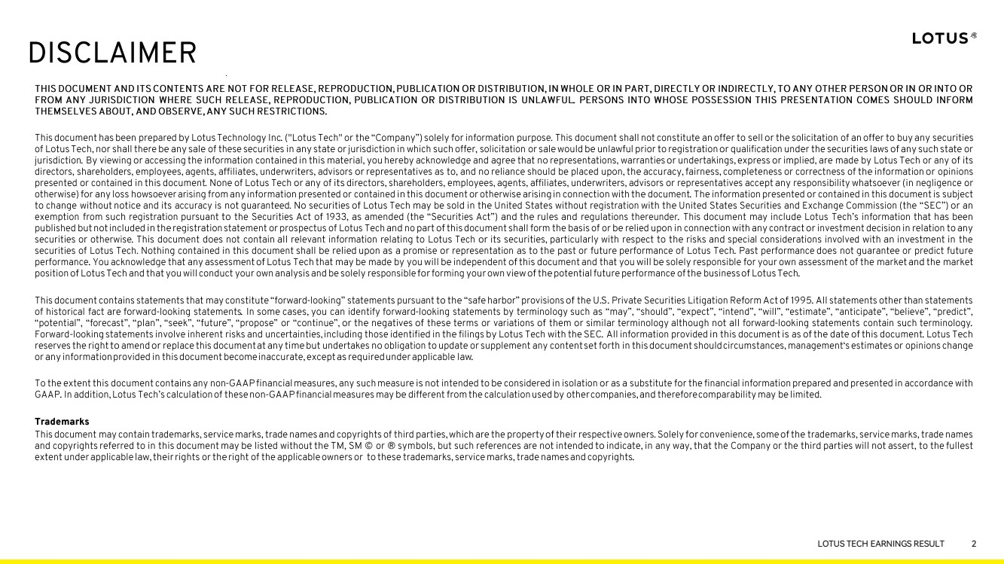 | R: 255 G: 255 B: 255 R: 242 G: 241 B: 240 R: 255 G: 247 B: 102 R: 255 G: 249 B: 153 R: 193 G: 192 B: 191 R: 247 G: 246 B: 246 R: 252 G: 252 B: 252 R: 114 G: 114 B: 114 R: 184 G: 184 B: 184 LOTUS TECH EARNINGS RESULT 2
 | 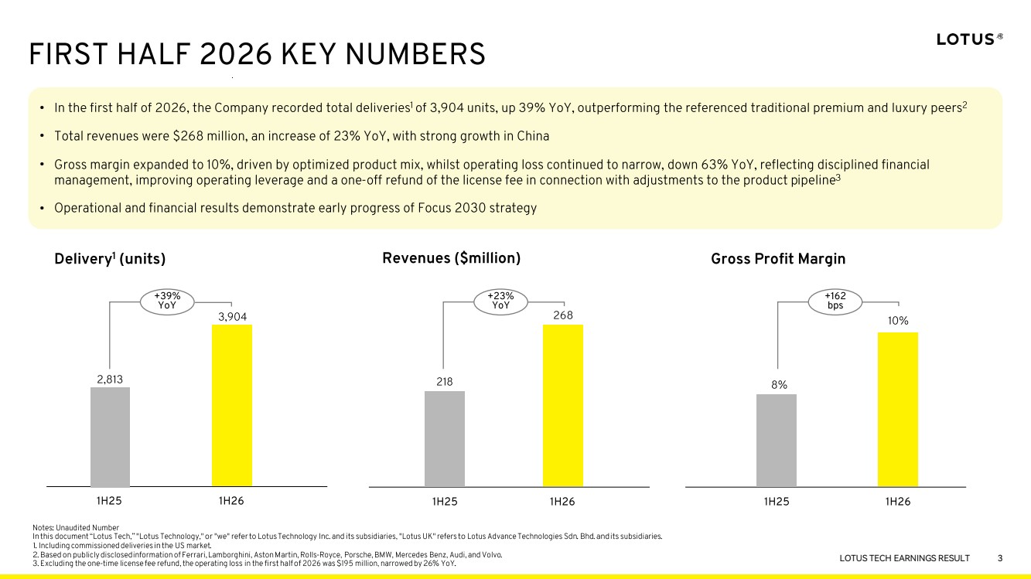 | R: 255 G: 255 B: 255 R: 242 G: 241 B: 240 R: 255 G: 247 B: 102 R: 255 G: 249 B: 153 R: 193 G: 192 B: 191 R: 247 G: 246 B: 246 R: 252 G: 252 B: 252 R: 114 G: 114 B: 114 R: 184 G: 184 B: 184 LOTUS TECH EARNINGS RESULT 3 • • • •
 | 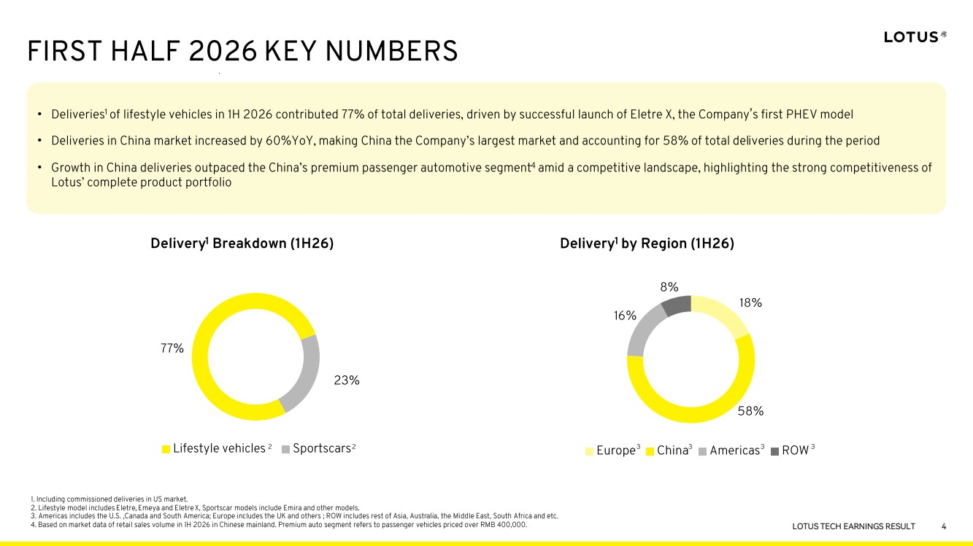 | R: 255 G: 255 B: 255 R: 242 G: 241 B: 240 R: 255 G: 247 B: 102 R: 255 G: 249 B: 153 R: 193 G: 192 B: 191 R: 247 G: 246 B: 246 R: 252 G: 252 B: 252 R: 114 G: 114 B: 114 R: 184 G: 184 B: 184 LOTUS TECH EARNINGS RESULT 4 • ’ • •
 | 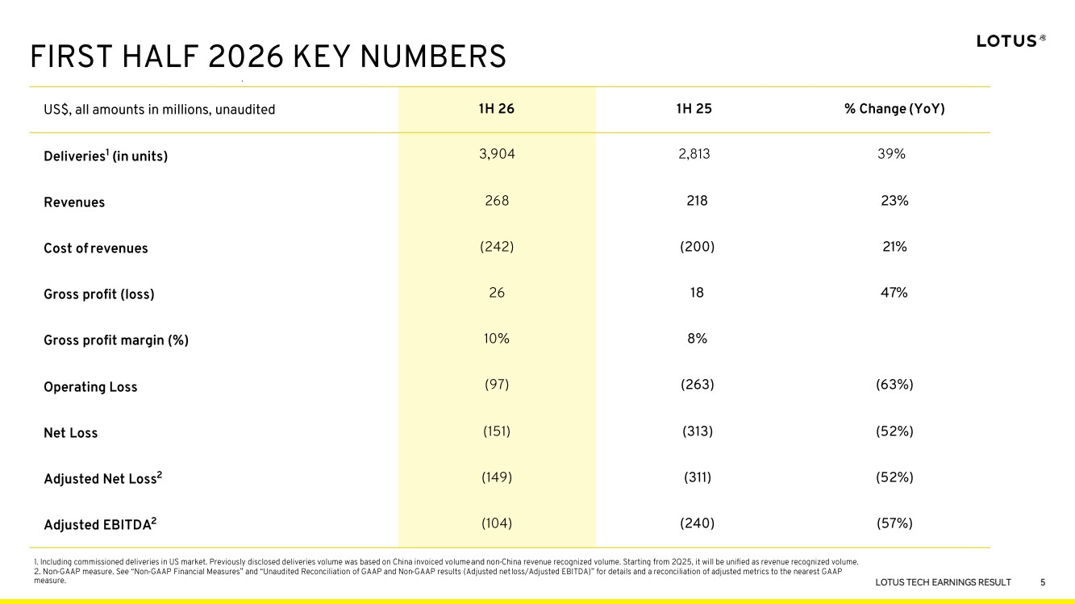 | R: 255 G: 255 B: 255 R: 242 G: 241 B: 240 R: 255 G: 247 B: 102 R: 255 G: 249 B: 153 R: 193 G: 192 B: 191 R: 247 G: 246 B: 246 R: 252 G: 252 B: 252 R: 114 G: 114 B: 114 R: 184 G: 184 B: 184 LOTUS TECH EARNINGS RESULT 5
 | 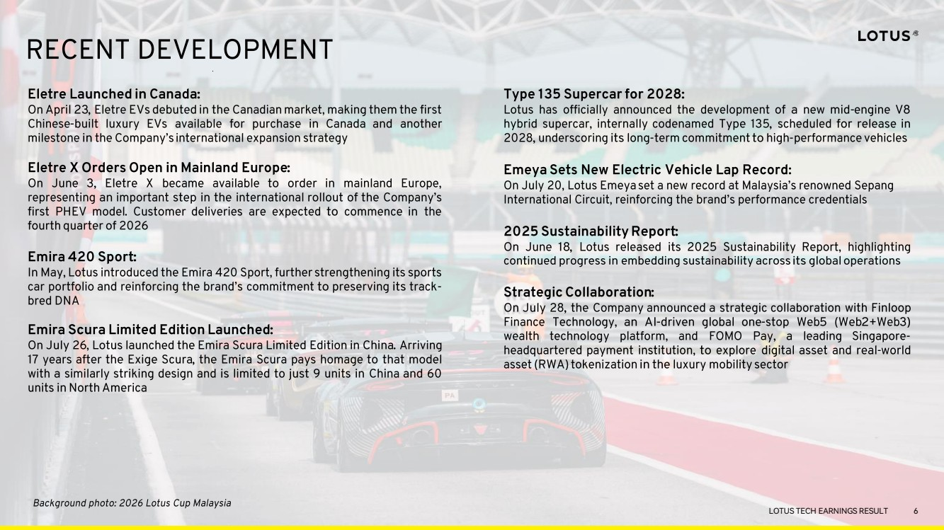 | R: 255 G: 255 B: 255 R: 242 G: 241 B: 240 R: 255 G: 247 B: 102 R: 255 G: 249 B: 153 R: 193 G: 192 B: 191 R: 247 G: 246 B: 246 R: 252 G: 252 B: 252 R: 114 G: 114 B: 114 R: 184 G: 184 B: 184 LOTUS TECH EARNINGS RESULT 6
 | 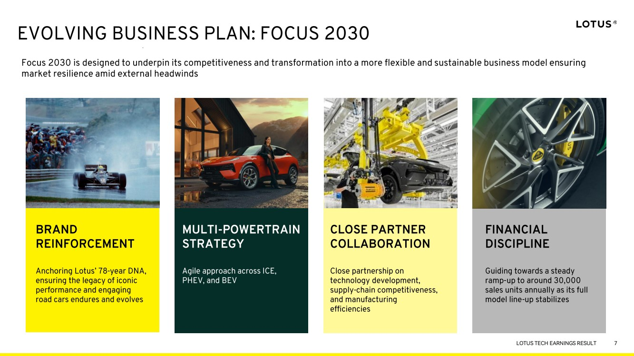 | R: 255 G: 255 B: 255 R: 242 G: 241 B: 240 R: 255 G: 247 B: 102 R: 255 G: 249 B: 153 R: 193 G: 192 B: 191 R: 247 G: 246 B: 246 R: 252 G: 252 B: 252 R: 114 G: 114 B: 114 R: 184 G: 184 B: 184 LOTUS TECH EARNINGS RESULT 7
 | 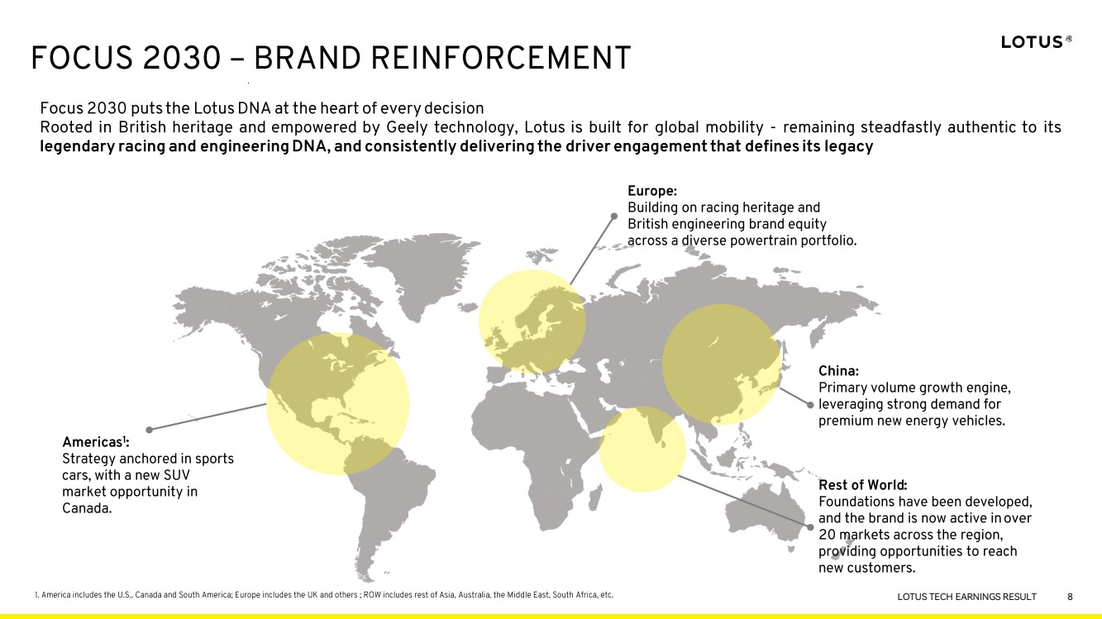 | R: 255 G: 255 B: 255 R: 242 G: 241 B: 240 R: 255 G: 247 B: 102 R: 255 G: 249 B: 153 R: 193 G: 192 B: 191 R: 247 G: 246 B: 246 R: 252 G: 252 B: 252 R: 114 G: 114 B: 114 R: 184 G: 184 B: 184 LOTUS TECH EARNINGS RESULT 8
 | 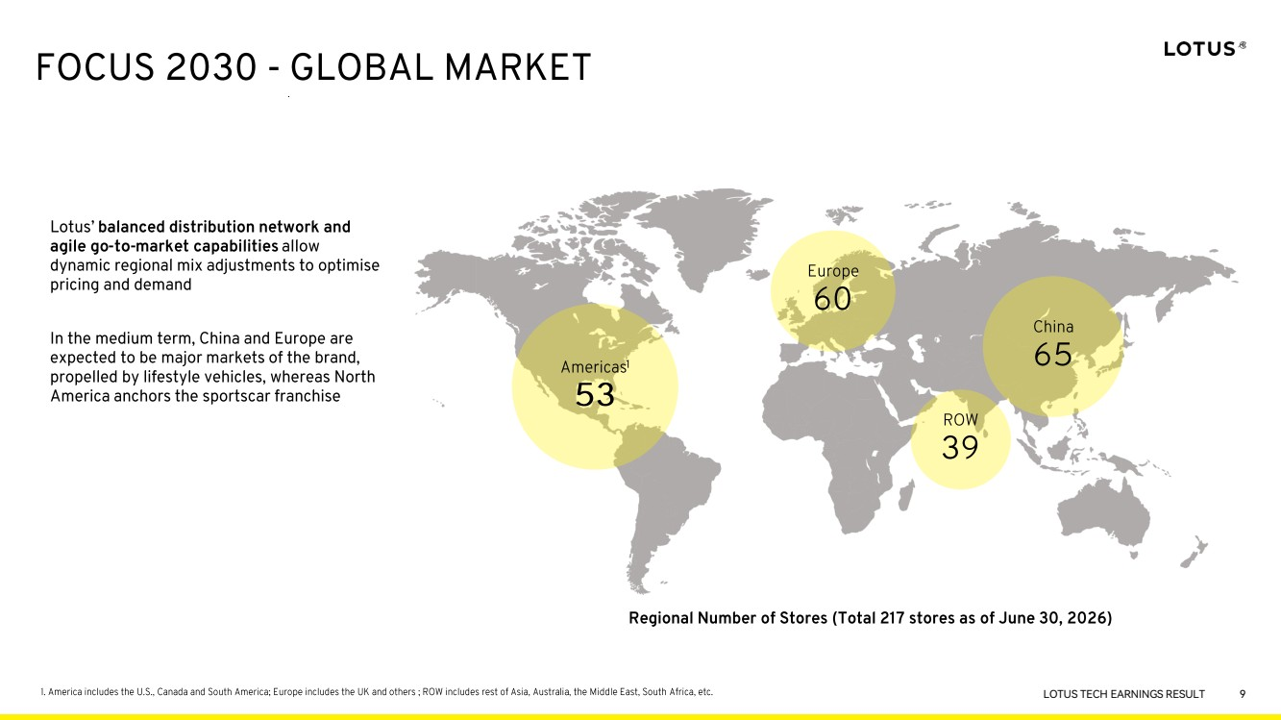 | R: 255 G: 255 B: 255 R: 242 G: 241 B: 240 R: 255 G: 247 B: 102 R: 255 G: 249 B: 153 R: 193 G: 192 B: 191 R: 247 G: 246 B: 246 R: 252 G: 252 B: 252 R: 114 G: 114 B: 114 R: 184 G: 184 B: 184 LOTUS TECH EARNINGS RESULT 9 9
 | 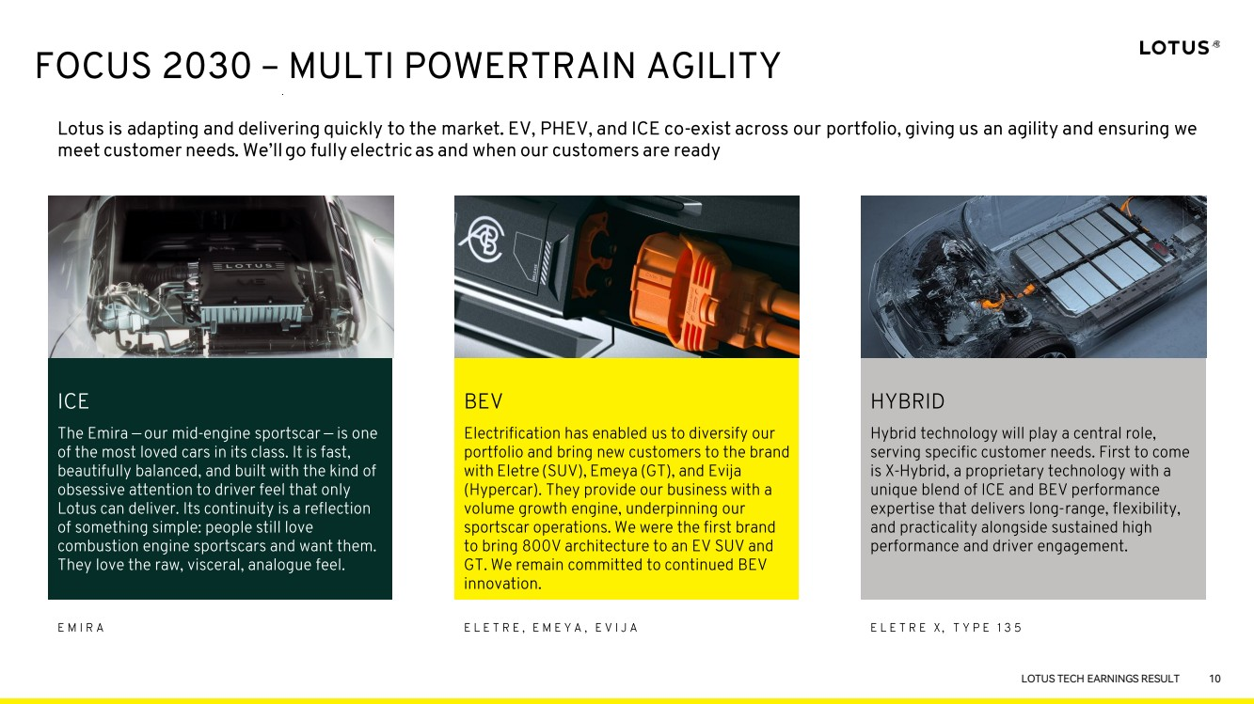 | R: 255 G: 255 B: 255 R: 242 G: 241 B: 240 R: 255 G: 247 B: 102 R: 255 G: 249 B: 153 R: 193 G: 192 B: 191 R: 247 G: 246 B: 246 R: 252 G: 252 B: 252 R: 114 G: 114 B: 114 R: 184 G: 184 B: 184 LOTUS TECH EARNINGS RESULT 10
 | 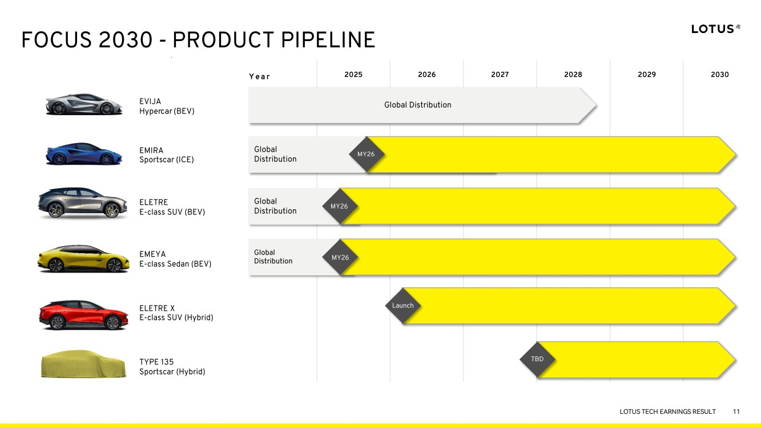 | R: 255 G: 255 B: 255 R: 242 G: 241 B: 240 R: 255 G: 247 B: 102 R: 255 G: 249 B: 153 R: 193 G: 192 B: 191 R: 247 G: 246 B: 246 R: 252 G: 252 B: 252 R: 114 G: 114 B: 114 R: 184 G: 184 B: 184 LOTUS TECH EARNINGS RESULT 11
 | 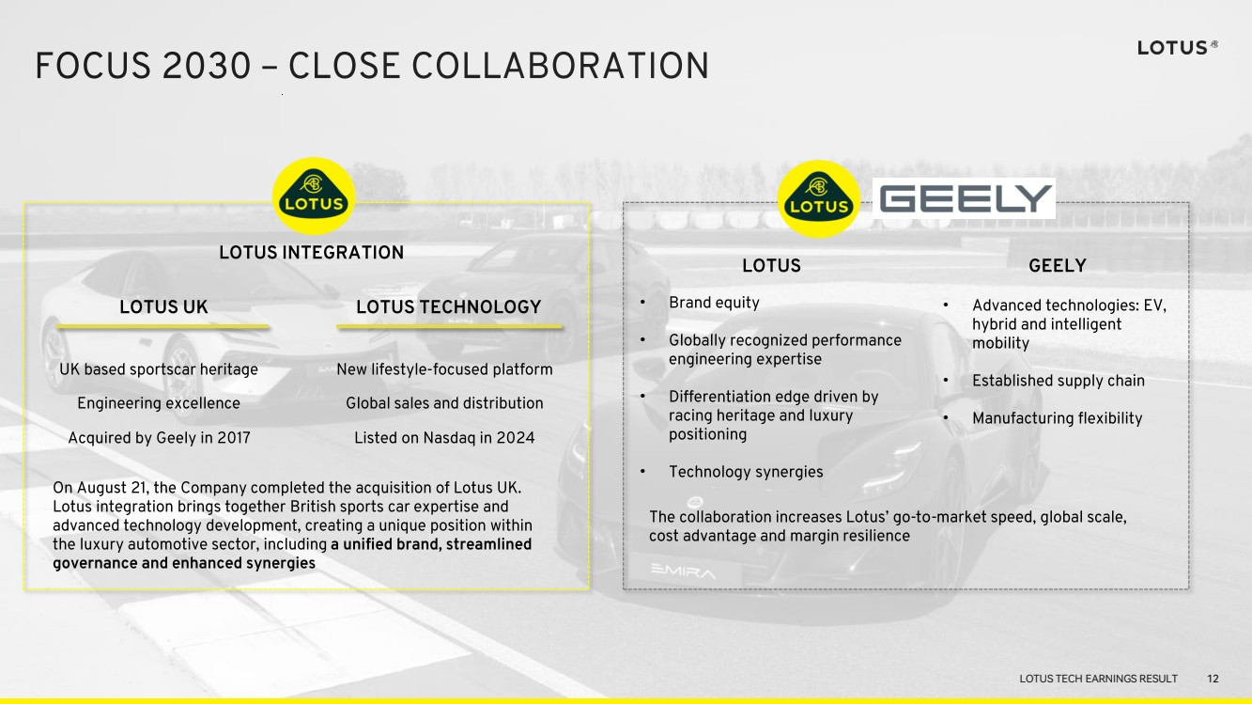 | R: 255 G: 255 B: 255 R: 242 G: 241 B: 240 R: 255 G: 247 B: 102 R: 255 G: 249 B: 153 R: 193 G: 192 B: 191 R: 247 G: 246 B: 246 R: 252 G: 252 B: 252 R: 114 G: 114 B: 114 R: 184 G: 184 B: 184 LOTUS TECH EARNINGS RESULT • • • • • • • 12
 | 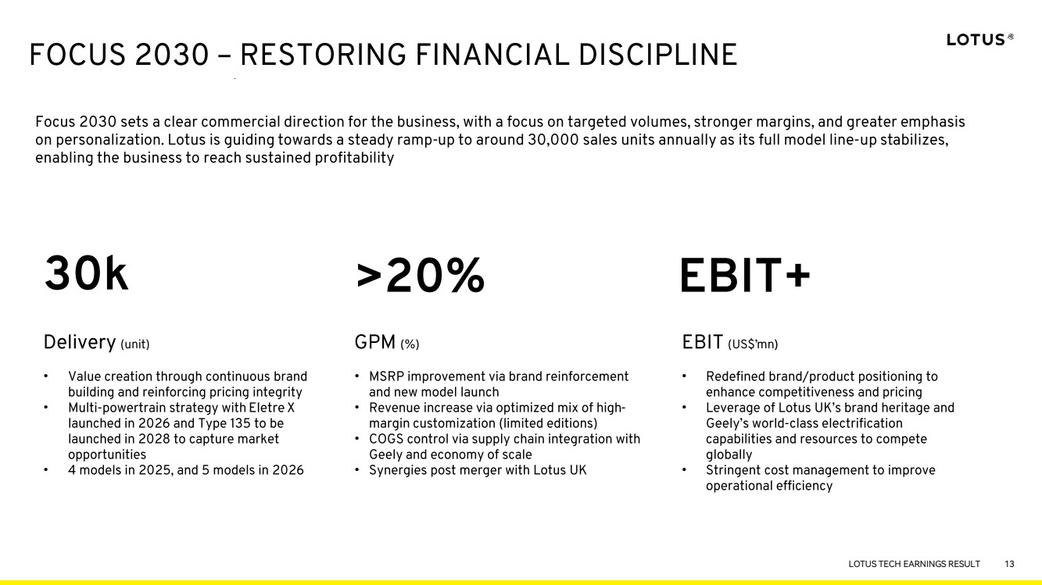 | R: 255 G: 255 B: 255 R: 242 G: 241 B: 240 R: 255 G: 247 B: 102 R: 255 G: 249 B: 153 R: 193 G: 192 B: 191 R: 247 G: 246 B: 246 R: 252 G: 252 B: 252 R: 114 G: 114 B: 114 R: 184 G: 184 B: 184 LOTUS TECH EARNINGS RESULT 13 • • • • • • • • • • 13
 |  | R: 255 G: 255 B: 255 R: 242 G: 241 B: 240 R: 255 G: 247 B: 102 R: 255 G: 249 B: 153 R: 193 G: 192 B: 191 R: 247 G: 246 B: 246 R: 252 G: 252 B: 252 R: 114 G: 114 B: 114 R: 184 G: 184 B: 184 LOTUS TECH EARNINGS RESULT APPENDIX 14
 | 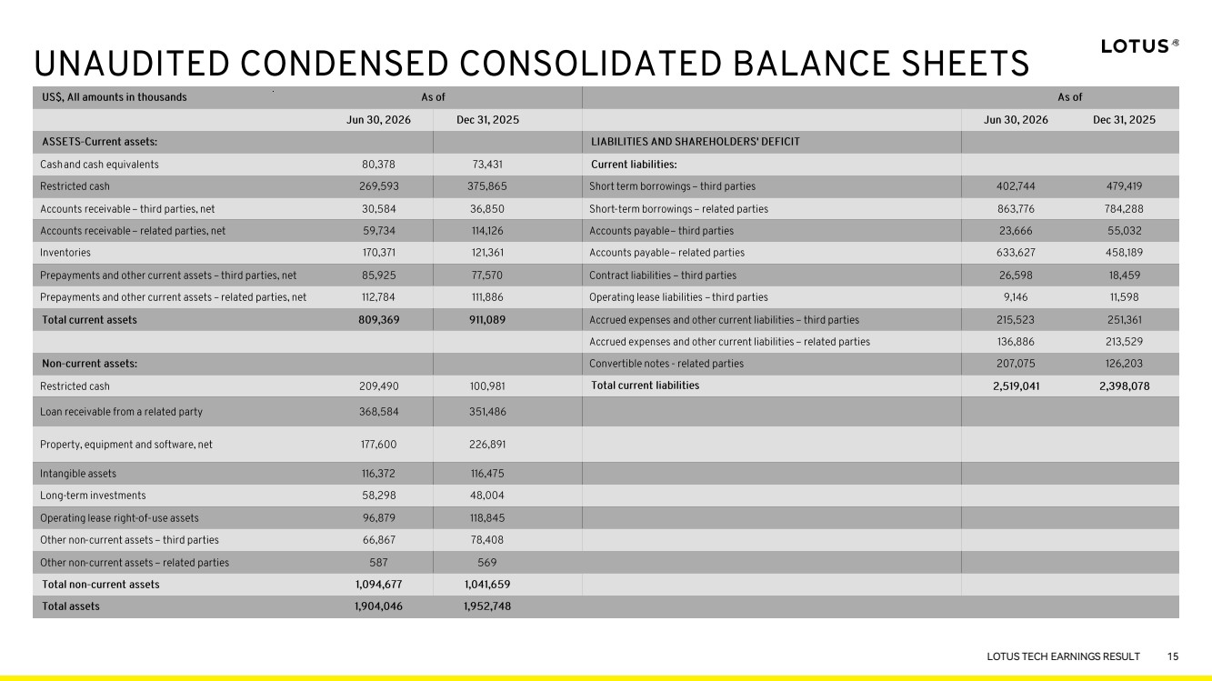 | R: 255 G: 255 B: 255 R: 242 G: 241 B: 240 R: 255 G: 247 B: 102 R: 255 G: 249 B: 153 R: 193 G: 192 B: 191 R: 247 G: 246 B: 246 R: 252 G: 252 B: 252 R: 114 G: 114 B: 114 R: 184 G: 184 B: 184 LOTUS TECH EARNINGS RESULT 15
 | 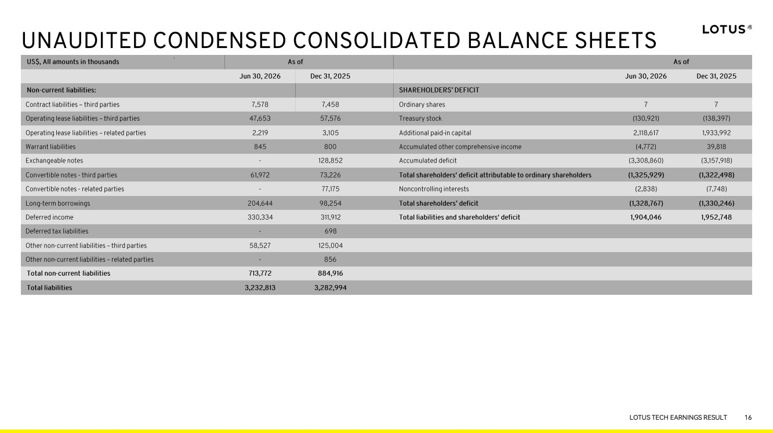 | R: 255 G: 255 B: 255 R: 242 G: 241 B: 240 R: 255 G: 247 B: 102 R: 255 G: 249 B: 153 R: 193 G: 192 B: 191 R: 247 G: 246 B: 246 R: 252 G: 252 B: 252 R: 114 G: 114 B: 114 R: 184 G: 184 B: 184 LOTUS TECH EARNINGS RESULT 16
 | 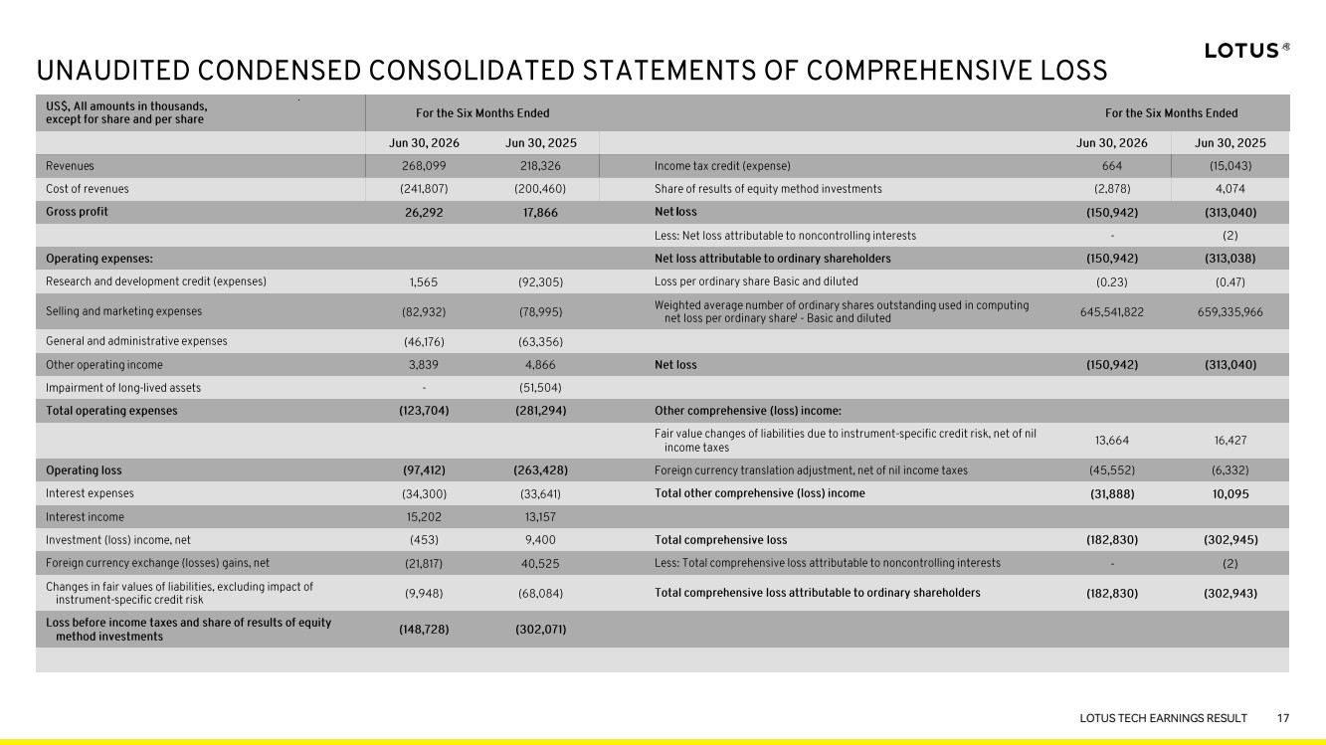 | R: 255 G: 255 B: 255 R: 242 G: 241 B: 240 R: 255 G: 247 B: 102 R: 255 G: 249 B: 153 R: 193 G: 192 B: 191 R: 247 G: 246 B: 246 R: 252 G: 252 B: 252 R: 114 G: 114 B: 114 R: 184 G: 184 B: 184 LOTUS TECH EARNINGS RESULT 17
 | 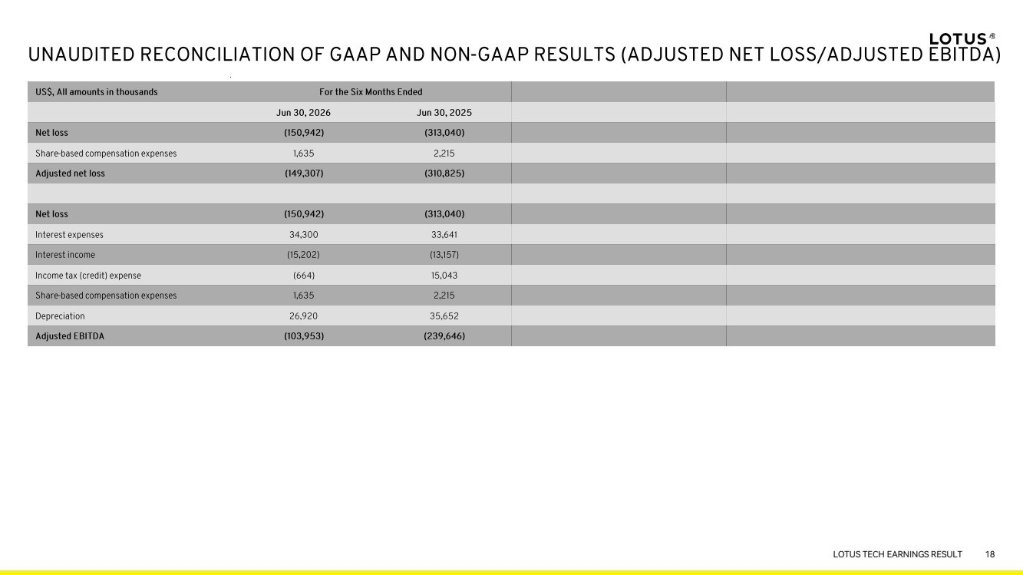 | R: 255 G: 255 B: 255 R: 242 G: 241 B: 240 R: 255 G: 247 B: 102 R: 255 G: 249 B: 153 R: 193 G: 192 B: 191 R: 247 G: 246 B: 246 R: 252 G: 252 B: 252 R: 114 G: 114 B: 114 R: 184 G: 184 B: 184 LOTUS TECH EARNINGS RESULT 18
 |  | R: 255 G: 255 B: 255 R: 242 G: 241 B: 240 R: 255 G: 247 B: 102 R: 255 G: 249 B: 153 R: 193 G: 192 B: 191 R: 247 G: 246 B: 246 R: 252 G: 252 B: 252 R: 114 G: 114 B: 114 R: 184 G: 184 B: 184 LOTUS TECH EARNINGS RESULT
 |  | R: 255 G: 255 B: 255 R: 242 G: 241 B: 240 R: 255 G: 247 B: 102 R: 255 G: 249 B: 153 R: 193 G: 192 B: 191 R: 247 G: 246 B: 246 R: 252 G: 252 B: 252 R: 114 G: 114 B: 114 R: 184 G: 184 B: 184 THANK YOU <PUBLIC> ir.group-lotus.com

