UNITED STATES
SECURITIES AND EXCHANGE COMMISSION
Washington, D.C. 20549

FORM 6-K

REPORT OF FOREIGN PRIVATE ISSUER PURSUANT TO RULE 13a-16 OR 15d-16 UNDER THE SECURITIES EXCHANGE ACT OF 1934

For the month of February 2024

Commission File Number: 001-41970

Lotus Technology Inc.
(Translation of registrant’s name into English)

No. 800 Century Avenue
Pudong District, Shanghai, People’s Republic of China
(Address of principal executive office)

Indicate by check mark whether the registrant files or will file annual reports under cover of Form 20-F or Form 40-F.

Form 20-F ☒ Form 40-F ☐

EXHIBIT INDEX

Exhibit No. |  | Description
99.1 |  | Press Release – Lotus Technology Celebrates Public Listing on Nasdaq

SIGNATURES

Pursuant to the requirements of the Securities Exchange Act of 1934, the registrant has duly caused this report to be signed on its behalf by the undersigned, thereunto duly authorized.

 | Lotus Technology Inc.
 | By | : | /s/ Alexious Kuen Long Lee
 | Name | : | Alexious Kuen Long Lee
 | Title | : | Director and Chief Financial Officer

Date: February 23, 2024

Exhibit 99.1

LOTUS TECH

group-lotus.com

Lotus Technology Celebrates Public Listing on Nasdaq

New York and Singapore - February 23, 2024 – Lotus Technology Inc. (“Lotus Tech” or the “Company”), a leading global luxury electric vehicle maker, rang today’s opening bell at the Nasdaq stock exchange in New York City in celebration of its public listing. The Company’s American depositary shares (“ADSs”) commenced trading today on the Nasdaq Stock Market LLC (“Nasdaq”) under the ticker symbol “LOT” following the completion of its business combination on February 22, 2024 with L Catterton Asia Acquisition Corp (“LCAA”), a special purpose acquisition company (“SPAC”) formed by affiliates of L Catterton, a leading global consumer-focused investment firm.

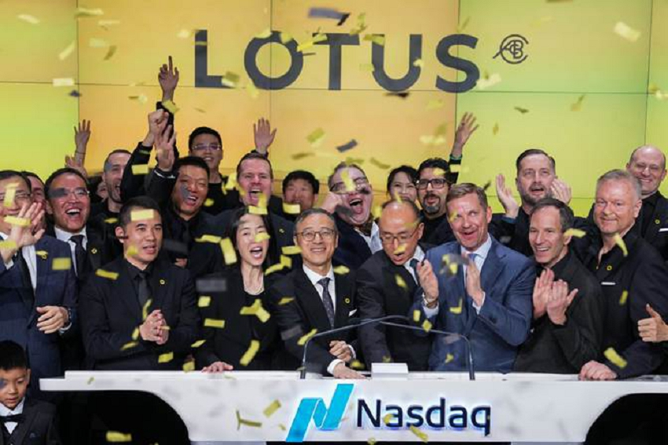

[Photo caption: Lotus Tech Debuts on NASDAQ.]

Lotus Tech CEO Feng Qingfeng was joined by members of the Lotus Tech and L Catterton teams in New York City to witness this important milestone, which will help Lotus Tech to further its mission of becoming an advanced, fully electric, intelligent, and sustainable luxury mobility provider under the brand’s Vision80 strategy.

“This is an exciting moment for all of us at Lotus Technology,” said Mr. Feng. “I would like to extend my appreciation to our shareholders, partners, suppliers, our outstanding employees, and most importantly, our customers, for their support. We are proud to carry Lotus’s heritage into the future, and to open a new chapter in the Lotus story with our public listing today.”

Chinta Bhagat, Co-Chief Executive Officer of LCAA said: “We believe that Lotus Tech is ideally positioned to seize the tremendous opportunity in the fast-growing and underserved luxury EV market, leveraging our global consumer insights and strategic relationship with LVMH. Today’s public listing is a significant step in the company’s future expansion and we are looking forward to our continued collaboration with Lotus Tech’s talented management team.”

The Nasdaq listing will support Lotus Tech’s development of next generation automobility technologies and the expected expansion of its global distribution network from around 200 to over 300 stores globally by 2025.

LOTUS TECH

group-lotus.com

Set to become the first traditional luxury auto brand to achieve a 100% electric product portfolio by 2027, the Company has launched a well-balanced portfolio of exceptionally performant models, including the Eletre hyper-SUV and Emeya hyper-GT, and plans to launch two additional luxury battery electric vehicles (BEV) over the next two years.

The bell-ringing ceremony was broadcast on Nasdaq’s digital billboards in Times Square and livestreamed online, with Lotus Tech employees joining the celebration remotely from offices across the world. The brand’s signature BEV models, Evija, Eletre and Emeya were also displayed in Times Square in front of the Nasdaq stock exchange.

– END –

About Lotus Technology

Lotus Technology Inc. has operations across China, the UK, and the EU. The Company is dedicated to delivering luxury lifestyle battery electric vehicles, with a focus on world-class R&D in next-generation automobility technologies such as electrification, digitalisation and more. For more information about Lotus Technology Inc., please visit www.group-lotus.com.

About L Catterton Asia Acquisition Corp

L Catterton Asia Acquisition Corp (NASDAQ: LCAA) is a blank check company incorporated for the purpose of effecting a merger, capital stock exchange, asset acquisition, stock purchase, reorganization or similar business combination with one or more businesses or entities. While it may pursue an initial target business in any industry or sector, it has focused its search on high-growth, consumer technology sectors across Asia. For more information about L Catterton Asia Acquisition Corp, please visit www.lcaac.com.

About L Catterton

L Catterton is a market-leading consumer-focused investment firm, managing approximately $35 billion of equity capital and three multi-product platforms: private equity, credit and real estate. Leveraging deep category insight, operational excellence, and a broad network of strategic relationships, L Catterton’s team of more than 200 investment and operating professionals across 17 offices partners with management teams to drive differentiated value creation across its portfolio. Founded in 1989, the firm has made over 275 investments in some of the world’s most iconic consumer brands. For more information about L Catterton, please visit www.lcatterton.com.

LOTUS TECH

group-lotus.com

Forward-Looking Statements

This press release (the “Press Release”) contains forward-looking statements within the meaning of Section 27A of the U.S. Securities Act of 1933, as amended (the “Securities Act”), and Section 21E of the U.S. Securities Exchange Act of 1934, that are based on beliefs and assumptions and on information currently available to Lotus Tech and LCAA. All statements other than statements of historical fact contained in this Press Release are forward-looking statements. In some cases, you can identify forward-looking statements by terminology such as “may”, “should”, “expect”, “intend”, “will”, “estimate”, “anticipate”, “believe”, “predict”, “potential”, “forecast”, “plan”, “seek”, “future”, “propose” or “continue”, or the negatives of these terms or variations of them or similar terminology although not all forward-looking statements contain such terminology. Such forward-looking statements are subject to risks, uncertainties, and other factors which could cause actual results to differ materially from those expressed or implied by such forward looking statements.

These forward-looking statements are based upon estimates and assumptions that, while considered reasonable by LCAA and its management, and Lotus Tech and its management, as the case may be, are inherently uncertain. Factors that may cause actual results to differ materially from current expectations include, but are not limited to: (1) the occurrence of any event, change or other circumstances that could give rise to the termination of definitive agreements with respect to the proposed Business Combination between LCAA, Lotus Tech and the other parties thereto (the “Business Combination”); (2) the outcome of any legal proceedings that may be instituted against LCAA, the Combined Company or others following the announcement of the Business Combination and any definitive agreements with respect thereto; (3) the amount of redemption requests made by LCAA public shareholders and the inability to complete the Business Combination due to the failure to obtain approval of the shareholders of LCAA, to obtain financing to complete the Business Combination or to satisfy other conditions to closing and; (4) changes to the proposed structure of the Business Combination that may be required or appropriate as a result of applicable laws or regulations or as a condition to obtaining regulatory approval of the Business Combination; (5) the ability to meet stock exchange listing standards following the consummation of the Business Combination; (6) the risk that the Business Combination disrupts current plans and operations of the Company as a result of the announcement and consummation of the Business Combination; (7) the ability to recognize the anticipated benefits of the Business Combination, which may be affected by, among other things, competition, the ability of the Combined Company to grow and manage growth profitably, maintain relationships with customers and suppliers and retain its management and key employees; (8) costs related to the Business Combination; (9) risks associated with changes in applicable laws or regulations and Lotus Tech’s international operations; (10) the possibility that Lotus Tech or the Combined Company may be adversely affected by other economic, business, and/or competitive factors; (11) Lotus Tech’s estimates of expenses and profitability; (12) Lotus Tech’s ability to maintain agreements or partnerships with its strategic partner Geely Holding and to develop new agreements or partnerships; (13) Lotus Tech’s ability to maintain relationships with its existing suppliers and strategic partners, and source new suppliers for its critical components, and to complete building out its supply chain, while effectively managing the risks due to such relationships; (14) Lotus Tech’s reliance on its partnerships with vehicle charging networks to provide charging solutions for its vehicles and its strategic partners for servicing its vehicles and their integrated software; (15) Lotus Tech’s ability to establish its brand and capture additional market share, and the risks associated with negative press or reputational harm, including from lithium-ion battery cells catching fire or venting smoke; (16) delays in the design, manufacture, launch and financing of Lotus Tech’s vehicles and Lotus Tech’s reliance on a limited number of vehicle models to generate revenues; (17) Lotus Tech’s ability to continuously and rapidly innovate, develop and market new products; (18) risks related to future market adoption of Lotus Tech’s offerings; (19) increases in costs, disruption of supply or shortage of materials, in particular for lithium-ion cells or semiconductors; (20) Lotus Tech’s reliance on its partners to manufacture vehicles at a high volume, some of which have limited experience in producing electric vehicles, and on the allocation of sufficient production capacity to Lotus Tech by its partners in order for Lotus Tech to be able to increase its vehicle production capacities; (21) risks related to Lotus Tech’s distribution model; (22) the effects of competition and the high barriers to entry in the automotive industry, and the pace and depth of electric vehicle adoption generally on Lotus Tech’s future business; (23) changes in regulatory requirements, governmental incentives and fuel and energy prices; (24) the impact of the global COVID-19 pandemic on LCAA, Lotus Tech, Lotus Tech’s post business combination’s projected results of operations, financial performance or other financial metrics, or on any of the foregoing risks; and (25) other risks and uncertainties set forth in the section entitled “Risk Factors” and “Cautionary Note Regarding Forward-Looking Statements” in Lotus Tech’s registration statement on Form F-4 (File No. 333-275001) filed by Lotus Tech with the U.S. Securities and Exchange Commission (the “SEC”) on January 12, 2024 and LCAA’s final prospectus relating to its initial public offering (File No. 333-253334) filed by LCAA with the SEC on March 12, 2021, and other documents filed, or to be filed, with the the SEC”) by LCAA or Lotus Tech, including the Registration/Proxy Statement (as defined below). There may be additional risks that neither LCAA nor Lotus Tech presently know or that LCAA or Lotus Tech currently believe are immaterial that could also cause actual results to differ from those contained in the forward-looking statements.

LOTUS TECH

group-lotus.com

Nothing in this Press Release should be regarded as a representation by any person that the forward-looking statements set forth herein will be achieved in any specified time frame, or at all, or that any of the contemplated results of such forward-looking statements will be achieved in any specified time frame, or at all. The forward-looking statements in this Press Release represent the views of LCAA and Lotus Tech as of the date they are made. While LCAA and Lotus Tech may update these forward-looking statements in the future, LCAA and Lotus Tech specifically disclaim any obligation to do so, except to the extent required by applicable law. You should not place undue reliance on forward-looking statements.

Contact Information
For inquiries regarding Lotus Tech
Demi Zhang
ir@group-lotus.com

Brunswick Group
Lotustechmedia@brunswickgroup.com

For inquiries regarding LCAA and/or L Catterton
Julie Hamilton (U.S.)
media@lcatterton.com
+1 203 742 5185

Bob Ong / Bonnie Gan (Asia)
bob.ong@lcatterton.com / bonnie.gan@lcatterton.com
+65 6672 7619 / +86 10 8555 1807

